CIT336 Midterm Exam Spring 2016

Code/Database will be 50% of the final grade, and the questions will be the other 50%, with each question having a value of 5 points.

We’re going to create an application that allows us to keep track of all of the ice cream cones sold at an ice cream stand so that we can eventually check if there are any trends in how we’re selling ice cream.

The Pace Ice Cream Shop sells five different flavors of ice cream: vanilla, chocolate, strawberry, mint chocolate chip, and cotton candy. It sells 3 different sizes: one scoop, two scoop, and three scoops.

We want to keep track of how many scoops we’re selling of each flavor at what time of the day.

So first, we will create a database to store this information.

We need one table, called ‘sales’, that will store each order, including the flavor of ice cream, how many scoops of it, and at what time the sale took place.

1. What would be the SQL to create this database and table?

CREATE DATABASE Test;

USE Test;

CREATE TABLE sales(order_id INT(6) AUTO_INCREMENT PRIMARY KEY, flavor VARCHAR(30), scoops VARCHAR(30), time VARCHAR(50));

Now that we have a database set up, we need to create a form to allow the cashier to enter the sales. It should look like this:



(Font is Arial, color is DeepSkyBlue)

Now we need to write a PHP file that will allow us to add the information from the form to the database.

2. What type of software do we need to have running on our computers to run PHP?

MAMP or HTTP server with PHP installed.

3. What type of variable must $link be if we’re using it throughout the document?

Object of the library that makes connection with the database.

Now we will write an AJAX function to send that data to the database without refreshing the page.

4. We’re using a GET request in this situation. In what situations might we choose to use a POST request instead?

GET requests let you pass information through the URL a POST request passes information through a post request.

5. What is AJAX and why are we using it?

Asynchronous JavaScript and XML. It is an alternative to use JavaScript and make http request without refreshing the page.

6. What is an HTTP request?

It is the request made for the HTTP protocol. A HTTP request is used to communicate between user’s computer and web server.

7. Where do we tell the client-side code what to do with the response from the server?

In the HTML file.

8. Is the AJAX on the server-side or client-side? Is the PHP on the client-side or server-side?

AJAX: Client-side. PHP: Server-side.

Double-check in your database that the information is being submitted.

Make a few theoretical ice cream sales.

Now we just want to take a quick peek at the sales we’ve made. Write a PHP file that displays a table that shows all of those sales. Add a link to the main page to this table.

It should look like this:

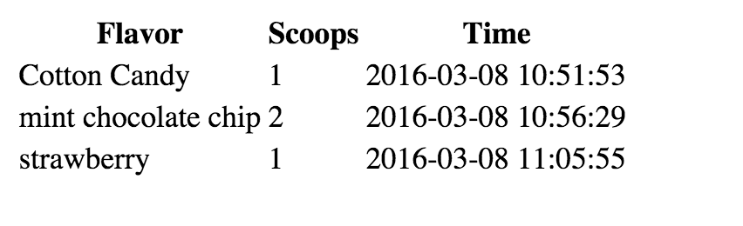

9. This application now does two of the functions of CRUD. Which two functions?

Create and Read.

10. Give me an example of 3 key-value pairs from your data.

$scoops = mysqli_real_escape_string($link, $_POST['scoops']);

$sql = "INSERT INTO sales (flavor, scoops) VALUES ('$flavor', '$scoops')";

var flavor = document.getElementsByName('selectionBox')[0].value;

11. If you were going to add this application to Github, what would be the steps to do that? Include the commands.

In the repository…

git add .

git commit –m”commit message”

git push origin master

12. What would be the benefits of using Github?

Git is a system for documents management (version control software) widely used for software development. With Git, people work together in a project using the same files. The reason for using Git is to work in projects as a team so that you have access to all versions of the code.

Did you document your code? Put in comments that explain what your code is doing.

Zip up a file with all of your code and this document and upload it to Blackboard.

Great job! Next week we are going to look at taking this data, and creating graphs so we know when we’re selling the most of what flavors.